Name of Student: HARPAL BIDAWAT | PRN:25070122080
Semester: III | Year: AY 2026-27
Subject: Programming with Java
ASSIGNMENT No: 27
TITLE: Develop a Java application demonstrating socket programming for communication between a client and a server.
Problem Statement
Develop a Java application demonstrating socket programming for communication between a client and a server.
Learning Objectives
To establish communication between client and server using Java sockets.
Programme
1.Create a simple client-server chat application using sockets.
2. Create a Java program using socket programming where the client sends a message to the server, and the server returns the same message back (echo system).
1)server

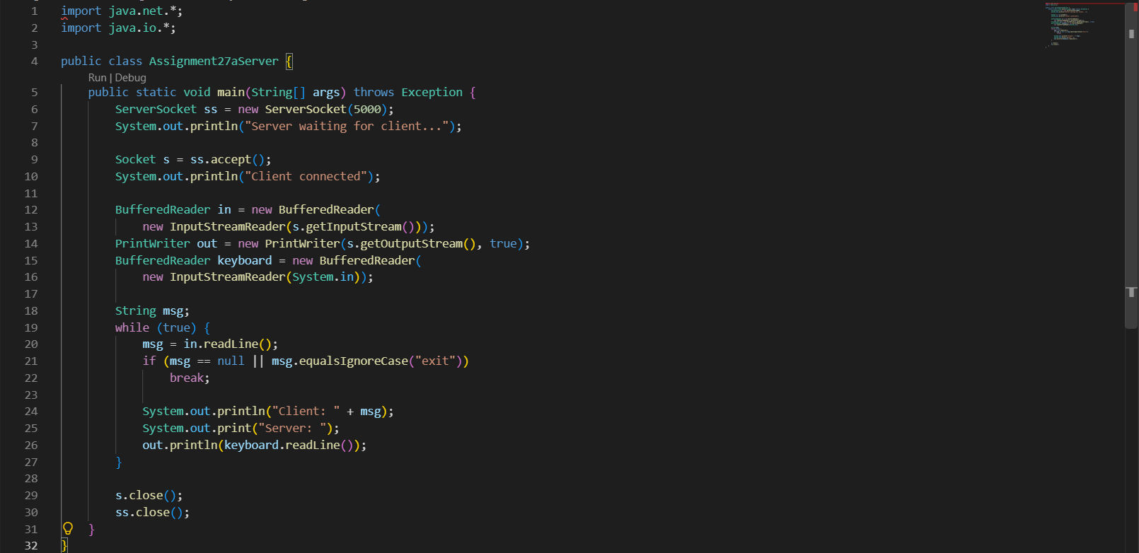
Client -
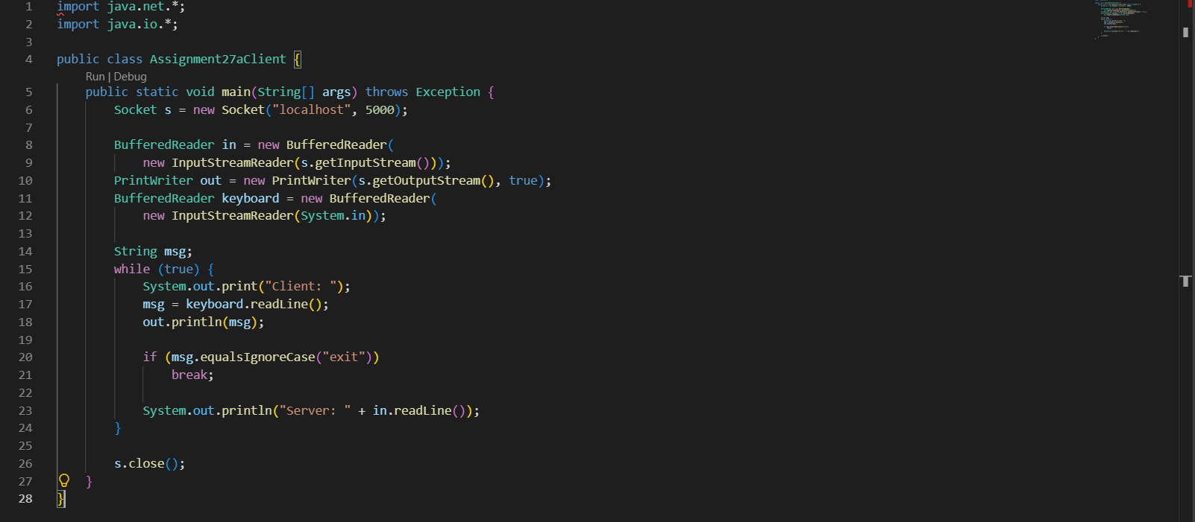

2)
Server-
- 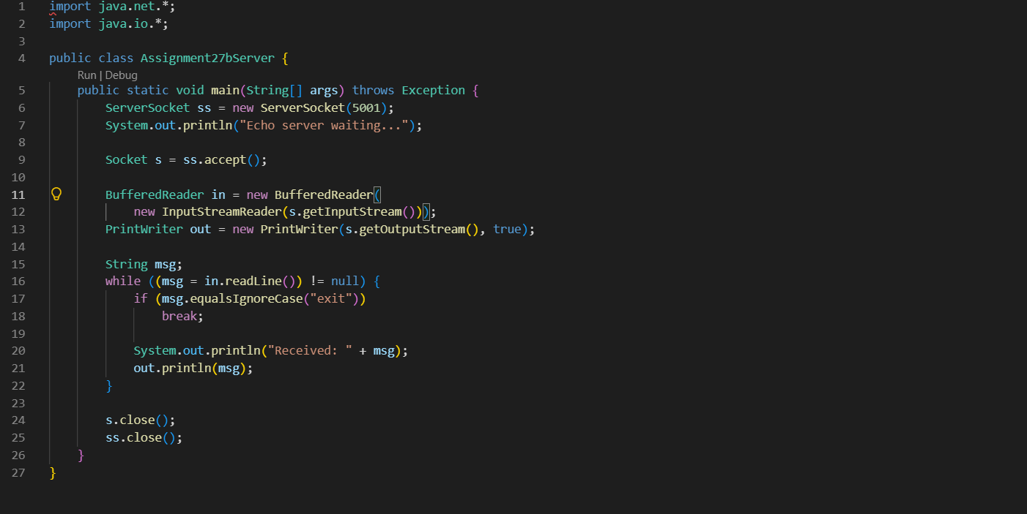
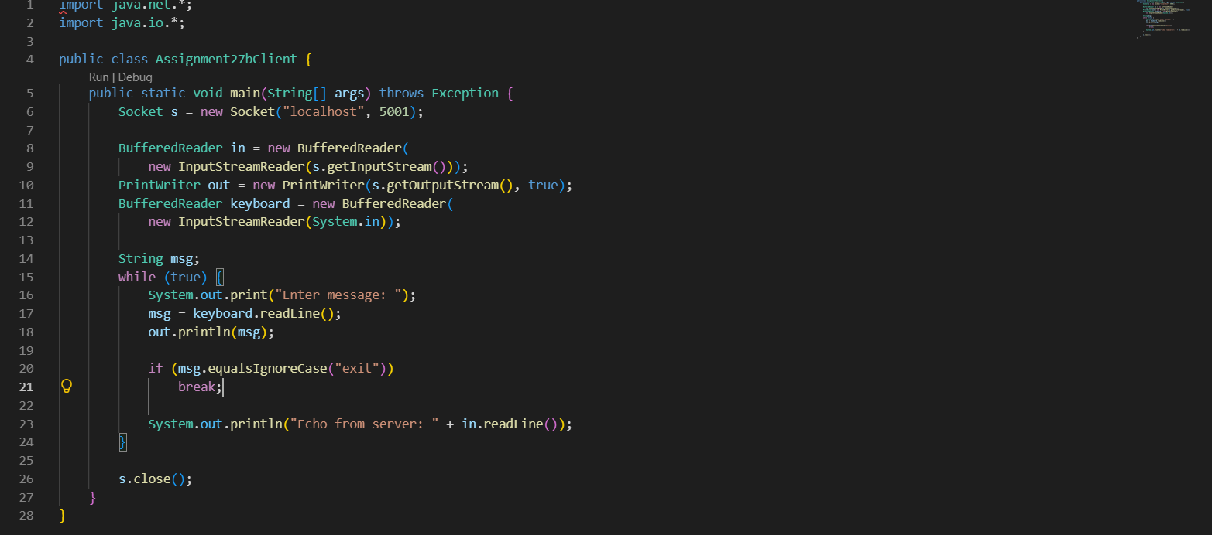
client -
Output
1)
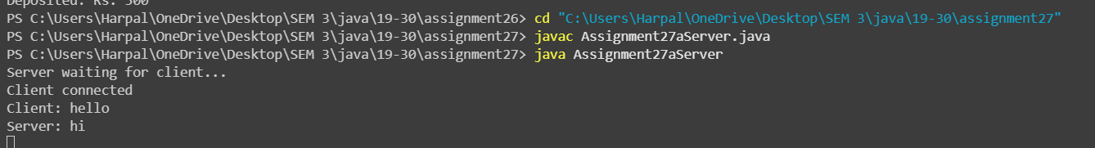
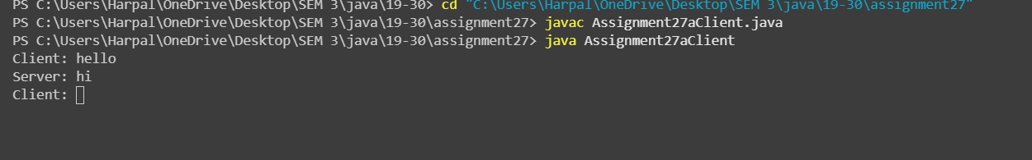

2)

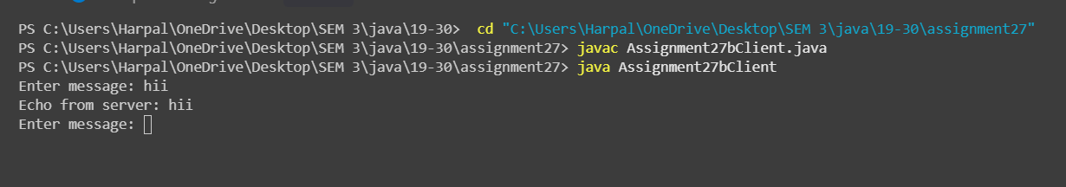
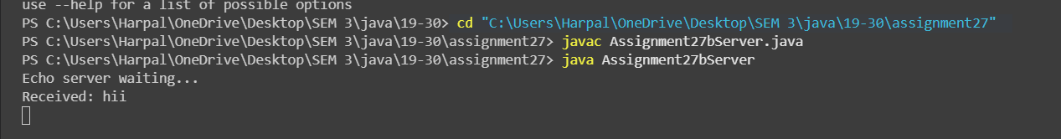
Conclusion
The program demonstrates client-server communication using Java socket programming. The chat application allows the client and server to exchange messages, illustrating basic network communication.

